**Battle of Neighborhood**

Aiswarya Sundaravelan

December 18, 2020.

**INTRODUCTION**

The aim of the project is to find which are in New York has the best of Indian cuisine. People all over the world has one thing in common they are starving for is to have a good food that yields a healthy life. A normal common man would be saying if he spends some amount in food that amount should be valuable to the food he had that night. Food has equally significant compared to money. If you have good health only, one can survive to earn money. This project deals with the process of analyzing “If I am in NYC, where will I go for a best rated indian cuisine.

This final project explores maximum area of the New York for Indian restaurants. [Manhattan](https://en.wikipedia.org/wiki/Manhattan) (New York County) is the geographically smallest and most densely populated borough, is home to [Central Park](https://en.wikipedia.org/wiki/Central_Park) and most of the city's skyscrapers, and is sometimes locally known as The City. Manhattan's population density of 72,033 people per square mile (27,812/km2) in 2015 makes it the [highest of any county in the United States](https://en.wikipedia.org/wiki/County_statistics_of_the_United_States#Population_density) and [higher than the density of any individual American city](https://en.wikipedia.org/wiki/List_of_United_States_cities_by_population_density#New_York_City_boroughs). Let’s make it more interesting by analyzing the data.

**BUISNESS PROBLEM**

The objective of this project is to find the best location for Indian cuisine to have. Using data science methodology and instruments such as Data analysis and Visuvalization, this project aims to provide solution to the business problem question : Which place in New York City is best for Indian cuisine.

**TARGET AUDIENCE**

The main target audience of this project is the common people who looks for a good food to have. As New York is a most diverse city in the whole world. With this diverse culture comes the diversity in the food items.There are many restaurants in New York City, each belonging to each categories like French, Japanese, Chinese and Indian.

**DATA**

Data to solve the problem, we will need the following data:

* New York City data containing the neighborhoods and boroughs.
* Latitude and longitude coordinates of those neighborhoods. This is required to plot the map and get the venue data.
* Venue data, particularly data related to restaurants.

We are going to use this data to perform further analysis of the neighborhoods. This project will require using of many data science skills, from web scrapping (open source dataset), working with API (Foursquare), data cleaning, data wrangling, to map visualization (Folium). In the next Methodology section, we will discuss and describe any exploratory data analysis that we did, any inferential statistical testing that we performed, and what machine learning techniques were used.

**METHODOLOGY**

* Data will be collected from https://cocl.us/new_york_dataset and cleaned and processed into a data frame.
* Foursquare be used to locate all venues and then filtered by Japanese restaurants. Ratings, tips, and likes by users will be counted and added to the data frame.
* Data will be sorted based on rankings.
* Finally, the data be will be visually assessed using graphing from Python libraries.

**OUTPUTS**

* We first got our New York data frame with the Borough, Neighborhood, Corresponding Latitude and Longitude. Following is the screenshot of our data frame New York
* This Data frame consist of data that we need to pursue with.

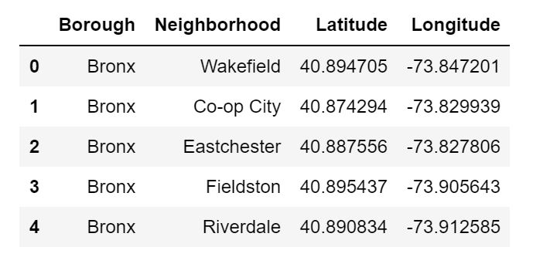

* Following we have created the bar plot inorder to analyze the insights from our input data.
* As we can see above graph that, the place "Queens" in New York has the most number of neighborhoods, on the other hand "Manhattan" has comparatively less number of neighborhoods.

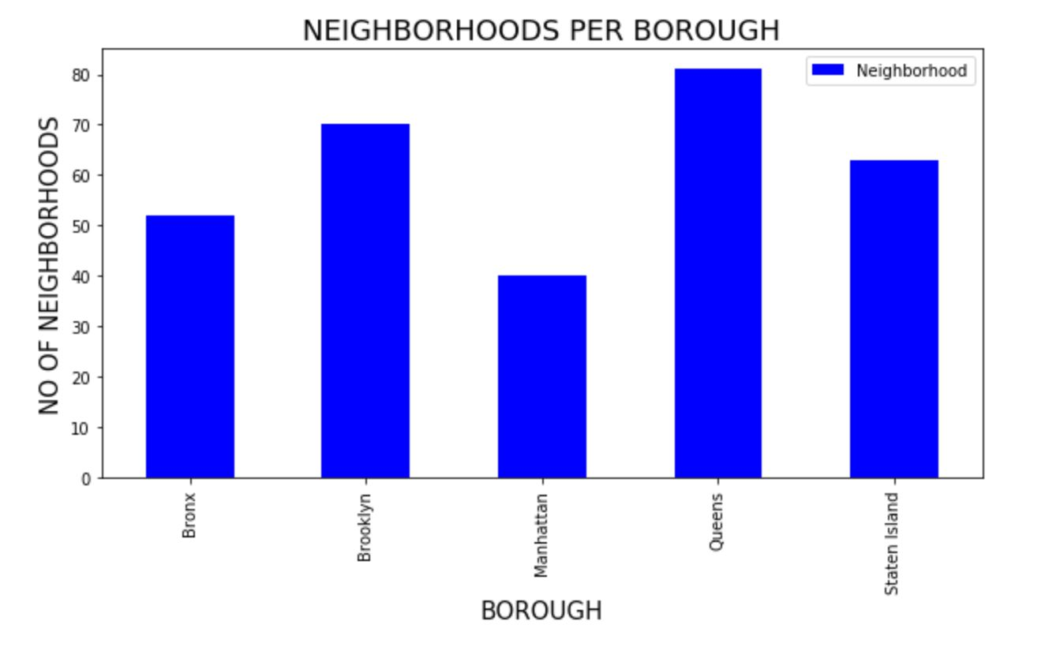

* After analyzing the data, I got to know that Bayside has the highest indian cuisines than any other areas in NY.

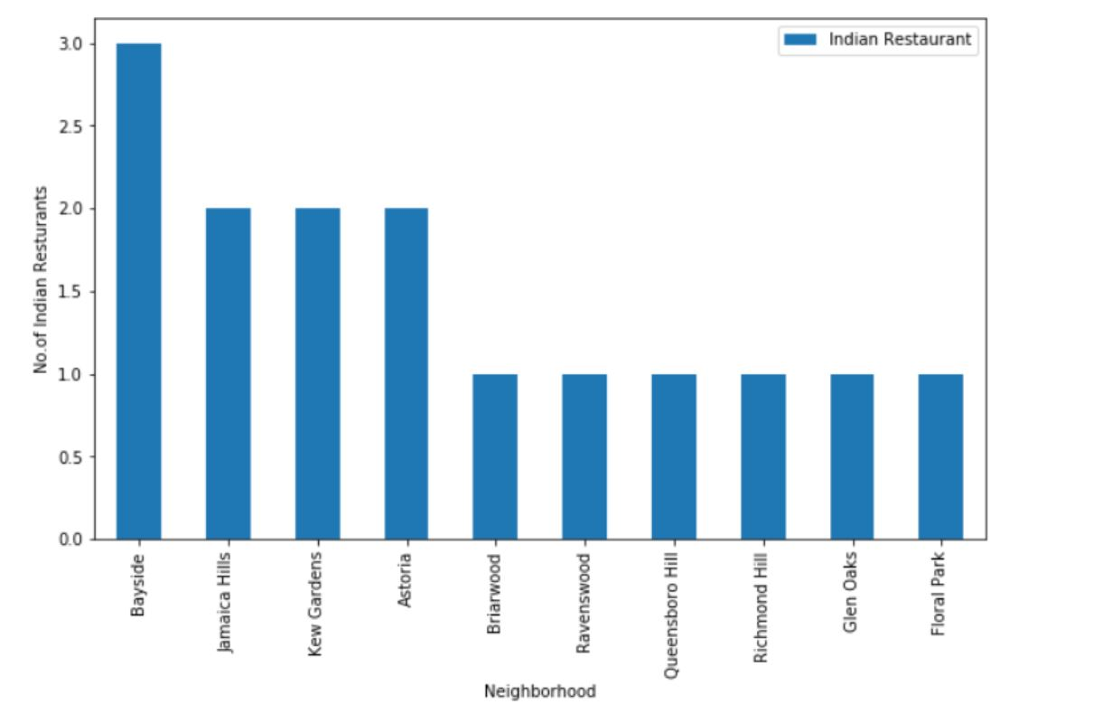

* Following is the folium map of result set.

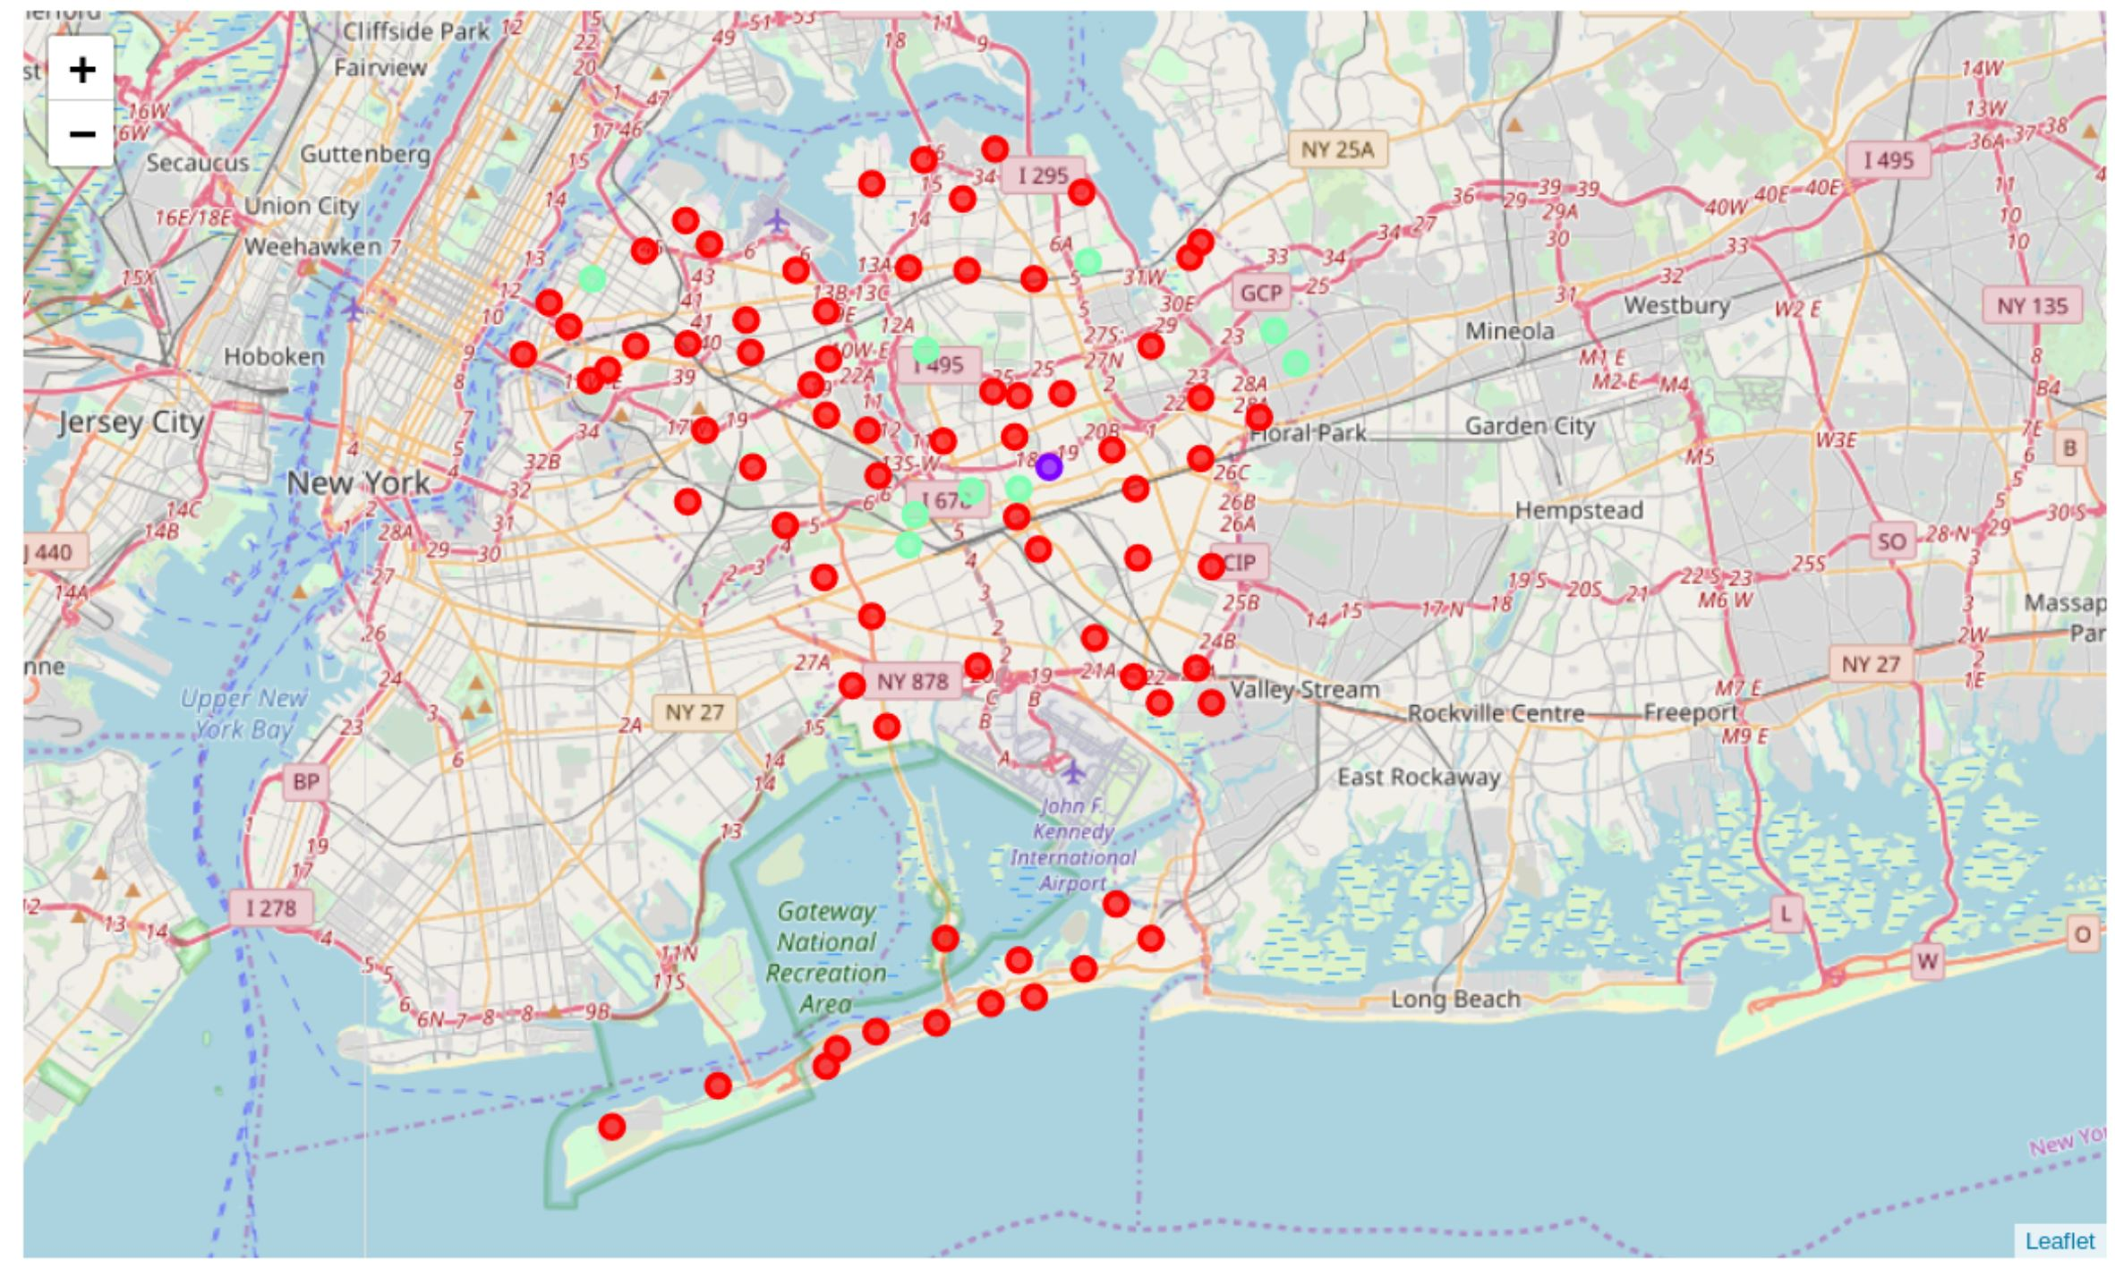

**DISCUSSION SECTION**

Based on the results of our analysis, I would state that Manhattan and Brooklyn are the best locations for Indian cuisine in NYC. Brooklyn has multiple neighborhoods with average ratings exceeding 8.0 on a scale of 1.0 to 10.0 and has less amount of Indian restaurants than Manhattan. Particularly, I would recommend considering trying a new food in Indian Restaurant either in Cobble Hill or in North Side, because both of these neighborhoods have the highest rating for Indian restaurants.

**CONCLUSION**

After analyzing all the way down, we came to a conclusion that New York is a good place to eat Indian cuisines. More accurately Brooklyn is the best place to have Indian cuisines as this place consist of more number of Indian cuisines and also with good ratings. Many good ratings which are above 8.0 rating are situated majority in Brooklyn. Secondly Manhattan is also a good place to eat Indian cuisines as this place also have certain very good Indian restaurants.